**GIT & GITHUB**

1 install git

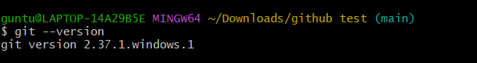

2Create a repo in github with README.md and .ignore file.

* Enter project name
* Choose visibility
* Add README
* Add. Gitignore , language python

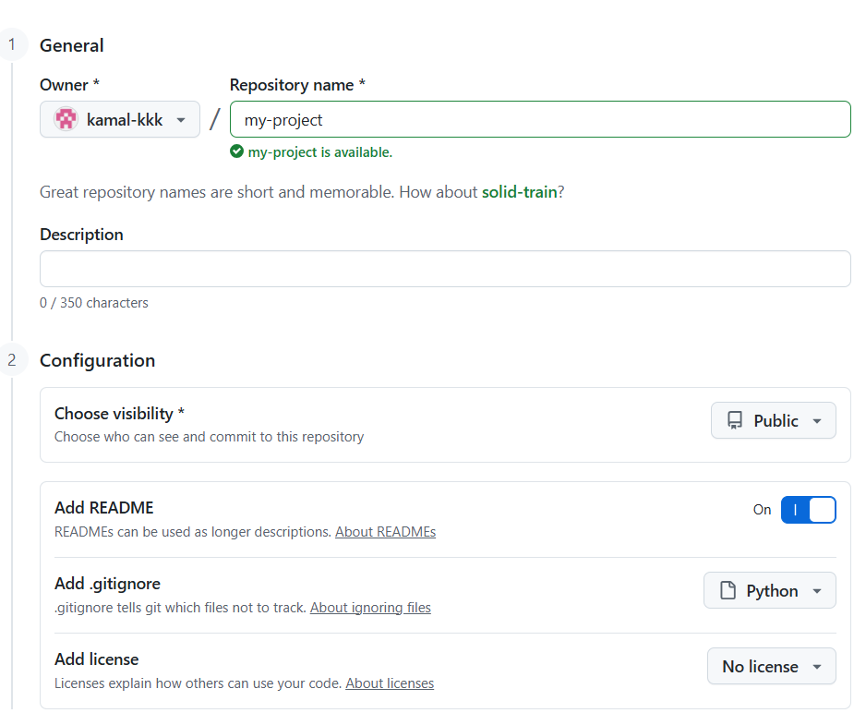

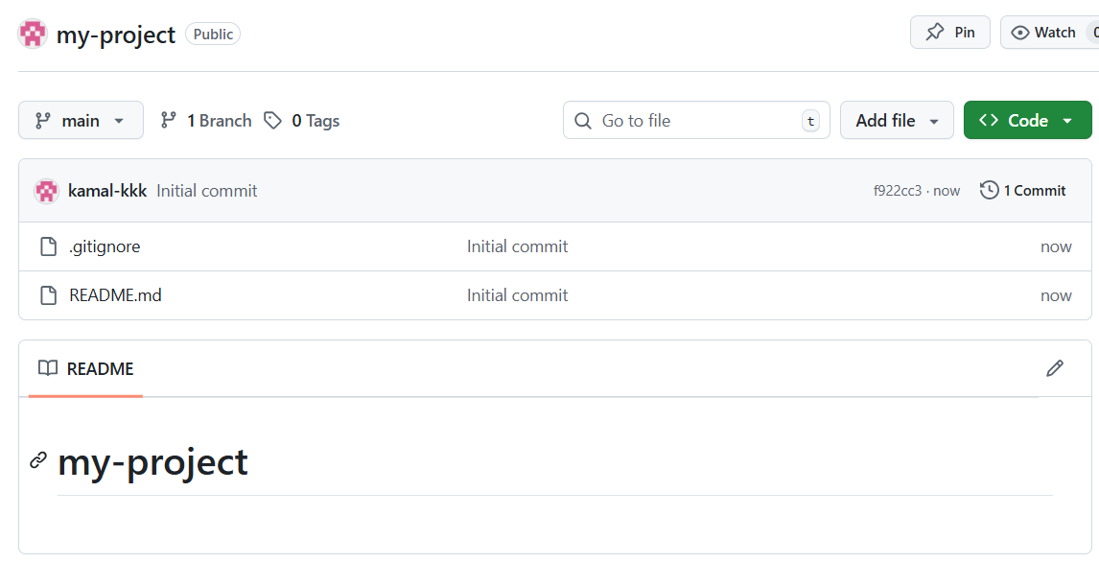

3.Clone the created repo to local**.**

Copy the url of the file

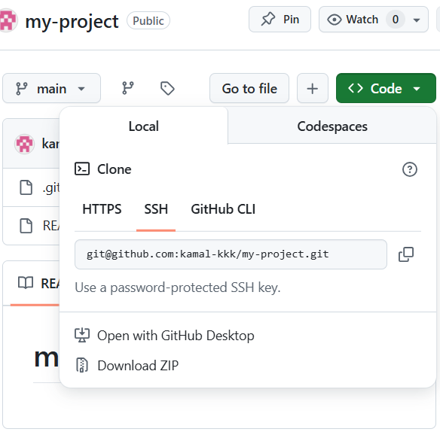

Open terminal and use command

Git clone [git@github.com:kamal-kkk/my-project.git](mailto:git@github.com:kamal-kkk/my-project.git)

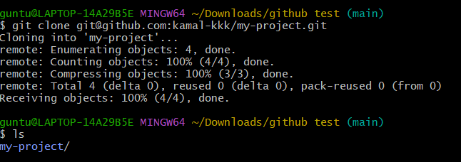

4. Create two files in local repo.

* go to repo

* enter command – touch file1 file2

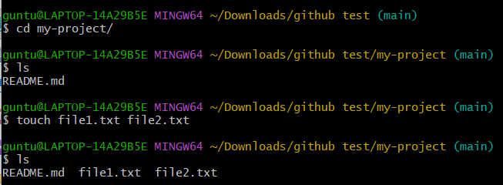

5. Commit two files and push to central Repository.

*list the files

*git add .

*commit the files – git commit -m ‘added file1.txt,file2.txt”

*and then push to central repo _ git push

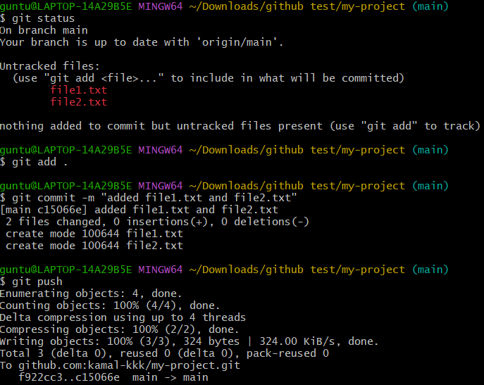

*refresh github

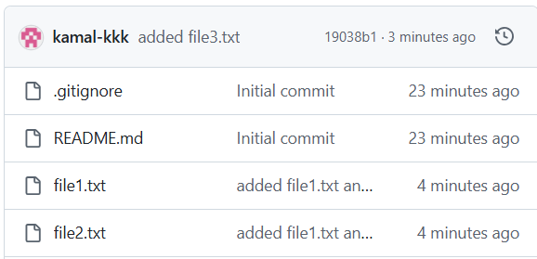

6. Create a branch in local and create a sample file and push to central.

*create e new branch using command git branch test

*switch to test branch = git switch test

*enter file = echo “testing file” > sample.txt

*git add .

* commit it = git commit -m “added sample.txt”

*git push origin test

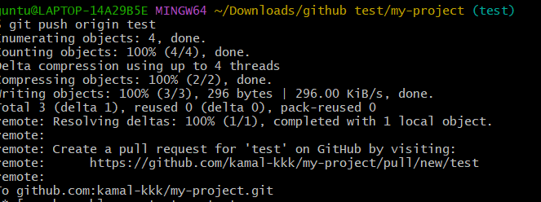

*check github can see new branch

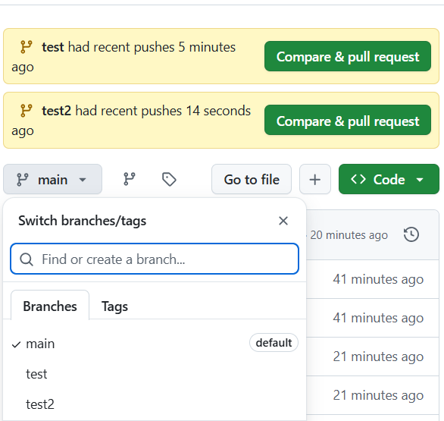

7. Create a branch in github and clone that to local.

*In project repo click branch and enter add branch with aname test3

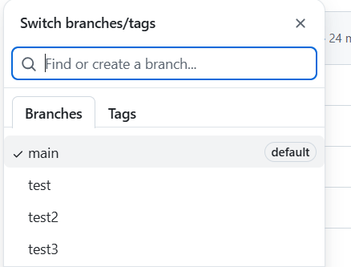

*in gitbash switch to test3 branch = git switch test3

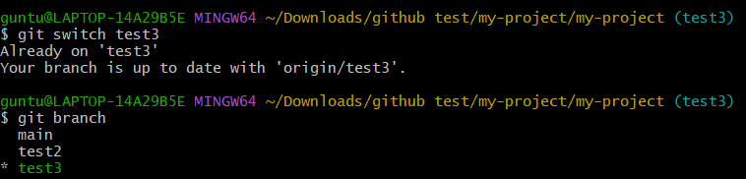

8. Merge the created branch with master in git local.

*git branch to check running branch

*git switch main

*now we are in main branch

*git merge test3

*git push origin main

Merging done

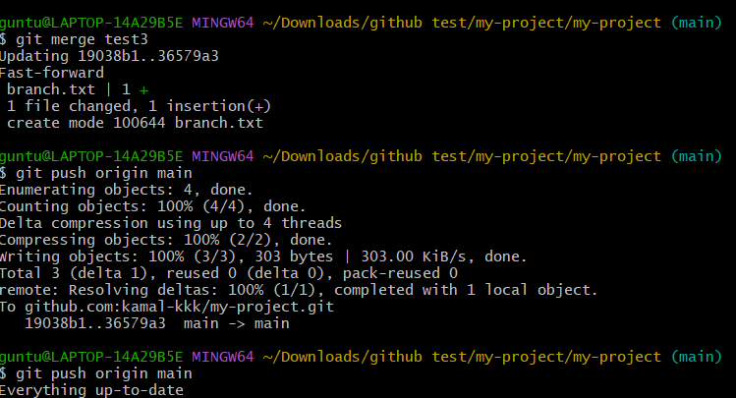

9. Merge the created branch with master in github by sending a pull request.

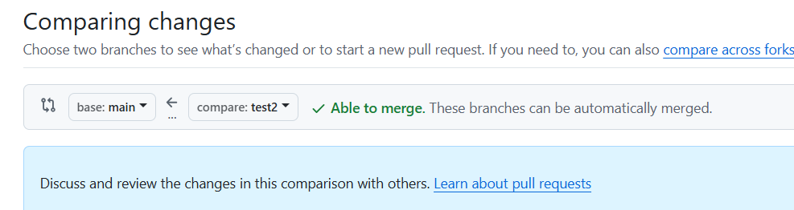

10. Create a file in local and send that to branch in github.

*create a repo

*add files as boxfile

*git add . to it

*git commit -m “added sample.txt”

*git push

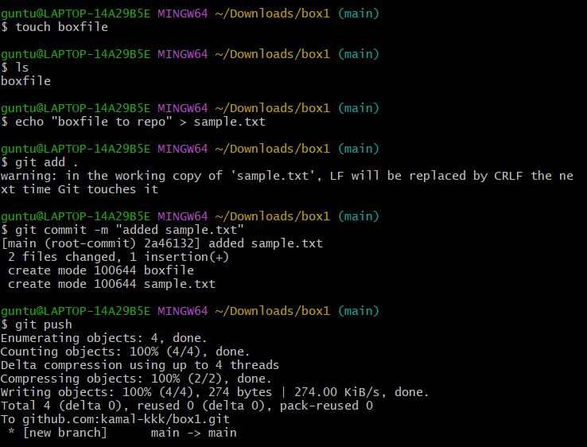

*refresh github

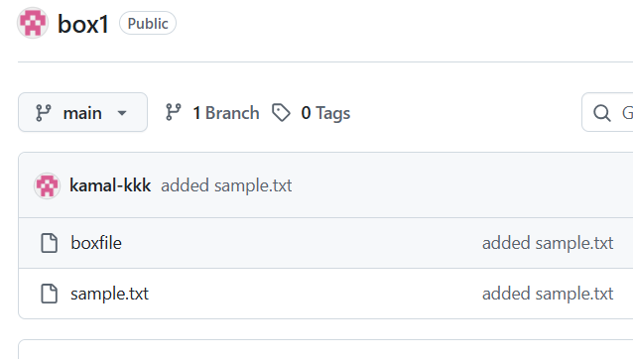

11. Clone only a branch from github to local.

*copy repo url

*command= git clone –branch test2 –single-branch [git@github.com:kamal-kkk/my-project.git](mailto:git@github.com:kamal-kkk/my-project.git)

*

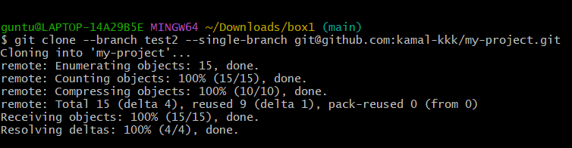

*verify = cd my-project

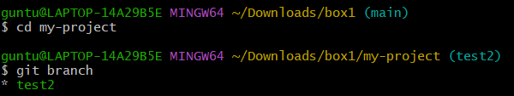

12. Create a file with all passwords and make that untrackable with git.

*created a file passwords

* enter passwords in the file using vi editor

*git init

*git commit -m “added top gitignore”

*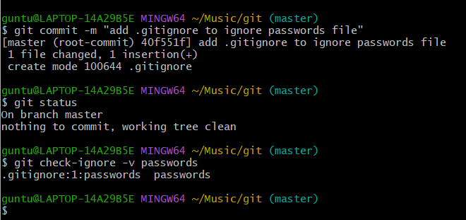

*to check = git check-ignore -v passwords

13.Make a commit and make that commit reset without savings changes.

*create a file with content

*echo “temporary content” > sample.txt

*git add .

*commit it = git commit -m “added file to sample.txt”

*git reset –hard HEAD~1

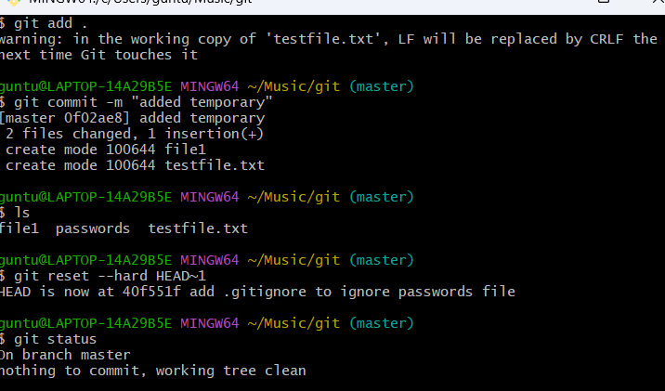

14.Revert a commited commit to the older version.

*git log = will get all the commit we have done

*coppy the first 5 digits of commit

*now, git revert {paste commit id}

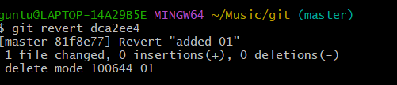

*editor will open ,just save it and close it

* now git push origin master

*file reverted

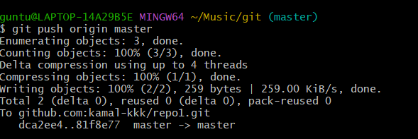

15.Push a file to stash without savings the changes and work on another file.

*git status

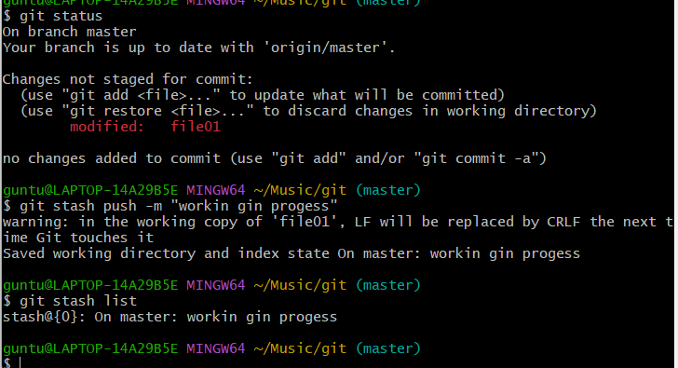

*now, use command = git stash push -m “workingon file01”

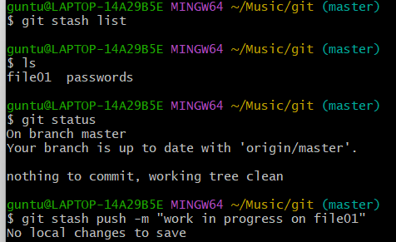

16. Undo the stash file and start working on that again.

*git stash list

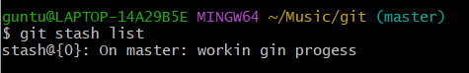

*git stash pop stash@{0}

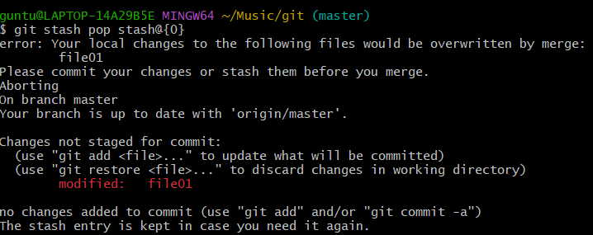

*git status

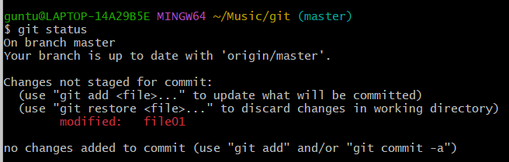

17.Generate a ssh-keygen and configure into github.

*ssh-keygen = to generate key

*SHA256:2/MvCsAul/2M4a5fuP58odFNYVOwj5GPdwBcvfLBx6o

*paste the generated key in github setting

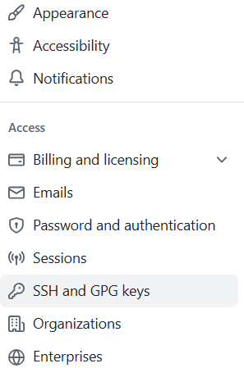

*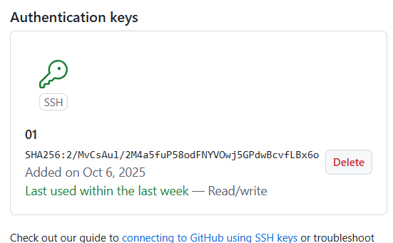

18. Configure webhooks to github.

*playload url required

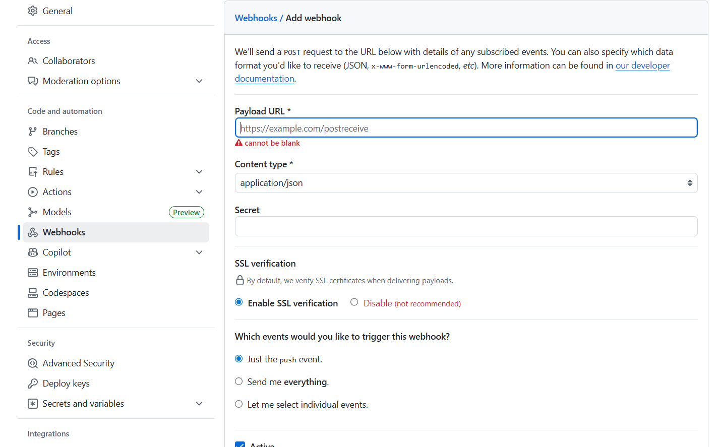

19. Basic understanding of .git file.

* Every Git repository has a hidden folder called .git in its root directory.

* It **stores info about repo**, including history, configuration, and staging info.

*] Think of it as the **database of your Git repo**—without it, Git won’t work.

20. heck all the logs of git.

*git log = can see all the commits

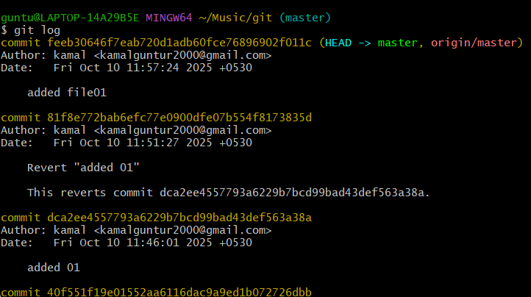

21. Rename the commit message

*command=- git commit –amend -m

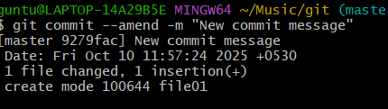

22. Merge multiple commits into single commit.

*git commit -m “merge conflicts”

*git push origin master

